**Software Documentation**

***Problem Statement : -*** In today's busy world , solving one’s day to day service related problems is little bit difficult The hectic schedule of urban people is so tight that they even don’t have time for food. The people who are new in town or even for the people who are living for years there is a need of a platform where they can easily find the assistance or help regarding their respective problems.

A platform (software or a website) is needed from where people can get the proper and verified information about the service providers or service related workers so that they can get ample amount of options for their respective service related problems at their fingertip.

***Solution :-*** For solving the above mentioned problem ,we are providing a mobile marketplace for local services. We help customers hire trusted professionals for all their service needs. We are staffed with young, passionate people working tirelessly to make a difference in the lives of people by catering to their service needs at their doorsteps.

We provide housekeeping services which consist of Plumbers, Electricians, Carpenters, Cleaning and Pest Control. We also provide personal services like mobile and other appliance repairs etc. Be it getting a plumbing job done, learning to play the guitar, decorating your home or getting candid photos of your wedding clicked, we are a sure shot destination for your service needs.

A dedicated platform (website) is made available to the people so that they can get the most trusted and verified information of the service providers nearby at the most affordable rate.

Software as a layered Architecture :-

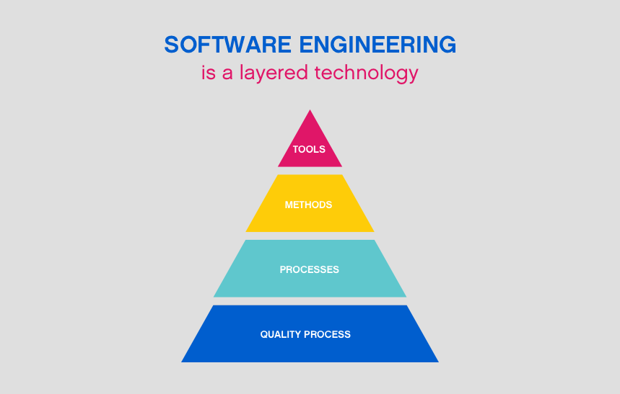

The presentation layer : It contains all categories related to the presentation layer.

The business layer : It contains business logic.

The persistence layer : It’s used for handling functions like object-relational mapping

The database layer : This is where all the data is stored.

*Software Process Model :-*

*Agile Manifesto:-* *The Agile Manifesto is a brief document built on 4 values and 12 principles for agile software development. The Agile Manifesto was published in February 2001 and is the work of 17 software development practitioners who observed the increasing need for an alternative to documentation-driven and heavyweight software development processes.*

*The 12 principles articulated in the Agile Manifesto are:*

* *Satisfying customers through early and continuous delivery of valuable work.*
* *Breaking big work down into smaller tasks that can be completed quickly.*
* *Recognizing that the best work emerges from self-organized teams.*
* *Providing motivated individuals with the environment and support they need and trusting them to get the job done.*
* *Creating processes that promote sustainable efforts.*
* *Maintaining a constant pace for completed work.*
* *Welcoming changing requirements, even late in a project.*
* *Assembling the project team and business owners on a daily basis throughout the project.*
* *Having the team reflect at regular intervals on how to become more effective, then tuning and adjusting behavior accordingly.*
* *Measuring progress by the amount of completed work.*
* *Continually seeking excellence.*
* *Harnessing change for a competitive advantage*

*Functional Requirements :-*A Functional Requirement is a description of services that our software is offering to our users . A function is nothing but inputs to the software system, its behavior, and outputs. It can be a calculation, data manipulation, business process, user interaction, or any other specific functionality which defines what function a system is likely to perform. The services offered by us are :-

* User can login for free to our website to access premium features offered by us.
* User can check and select the services offered by us based on their locality.
* User can compare between the various service providers .
* User can directly contact the service provider through our website.
* User can schedule date and time before contacting the service provider.

Non-Functional Requirements :- Nonfunctional requirements describe how a system must behave and establish constraints of its functionality. This type of requirements is also known as the system’s quality attributes. A non-functional requirement is a specification that describes the system’s operation capabilities and constraints that enhance its functionality .The non-functional requirements of our software are :-

* Users can change their login id and passwords.
* Our Website is capable of handling thousands of users without affecting the performance.
* Our Website reliable and accurate as it contains verified information about the service providers.